Report on testing of clauses management features when creating a canonical document
Steve Keyes, 5/25/2026

Browse Clause from Context menu
When I exercised this feature, I kept getting “File not found” from Word. I looked at the code an make a change that seemed to fix this feature:

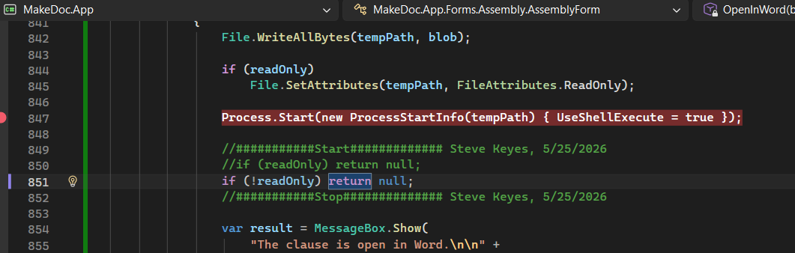

Edit from Context Menu
When I edit a clause (not in debug mode) I get a message from Word about “file no found”. If I run the same scenario in debug mode, and pause a few seconds before continuing from the break, it seems to work. This sounds like a “race” condition. I checked to make sure the temporary file was there – and it was.
I bigger question is why both the Browse and Edit clause context menu pick use the same code.

Delete clause from context menu
When I delete the clause, it is removed from the clause list. However, when I generate the document and attempt to open it, I get this message:
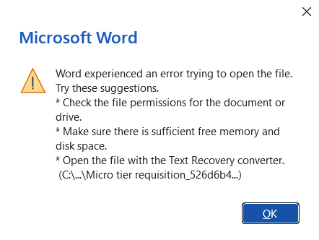
Move clause up from context menu
This works to move the clause in the clause list. However when I generate the document, I get the same error as for Delete clause.

Move clause down from context menu
Same as for Move up.

Reset clause list from context menu
Reset works to reset the clause list. But when I generate, I get the the Word message (above).

Note: when I just generate the document (no context menu operations) I get the Word message (above).

Insert Special clauses from context menu
I get this message:
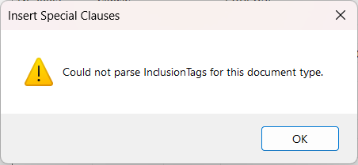

Generating Documents – scanning for fill-ins
When generating documents, MAKEDOC scans for fill-ins. For a Micro-Requisition, there should be a number of fill-ins (SDT) found, but only one is found. And, MAKEDOC reports the name of the fill-in as the current value of the fill-in: Click or tap here to enter text.
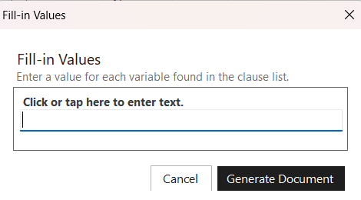

We do have an application that does successfully scan for fill-ins. It’s used in the REBUILD_MAKEDOC_DATABASE powershell script (FindSDTTagsApp). Here’s the source for the program.cs of that application:

using System;
using System.IO;
using System.Linq;
using DocumentFormat.OpenXml.Packaging;
using DocumentFormat.OpenXml.Wordprocessing;

namespace DocxSdtScanner
{
class Program
{
static void Main(string[] args)
{
string folderPath = @"C:\Users\skeye\BOOK2\MAKEDOC\docs\Clauses and assembled documents\clauses\micro\req";

if (args.Length > 0)
{
folderPath = args[0];
}

Console.WriteLine(folderPath);

if (!Directory.Exists(folderPath))
{
Console.WriteLine("Directory not found.");
return;
}

var docxFiles = Directory.GetFiles(folderPath, "*.docx", SearchOption.TopDirectoryOnly);

if (docxFiles.Length == 0)
{
Console.WriteLine("No DOCX files found.");
return;
}

foreach (var file in docxFiles)
{
Console.WriteLine($"\n=== {Path.GetFileName(file)} ===");

try
{
using (WordprocessingDocument doc = WordprocessingDocument.Open(file, false))
{
var body = doc.MainDocumentPart.Document.Body;

// All SDT elements in the document
var sdts = body.Descendants<SdtElement>().ToList();

// Keep only those with a non-empty Alias (= fill-ins)
var fillins = sdts
.Select(sdt => new
{
Title = sdt.SdtProperties?.GetFirstChild<SdtAlias>()?.Val?.Value,
Tag = sdt.SdtProperties?.GetFirstChild<Tag>()?.Val?.Value
})
.Where(x => !string.IsNullOrWhiteSpace(x.Title))
.ToList();

if (!fillins.Any())
{
// Console.WriteLine("No fill-ins found.");
continue;
}

foreach (var f in fillins)
{
Console.WriteLine($"Fill-in → Title: {f.Title}, Tag: {f.Tag ?? "(none)"}");
}
}
}
catch (Exception ex)
{
Console.WriteLine($"Error reading {file}: {ex.Message}");
}
}

Console.WriteLine("\nDone.");
}
}
}

